

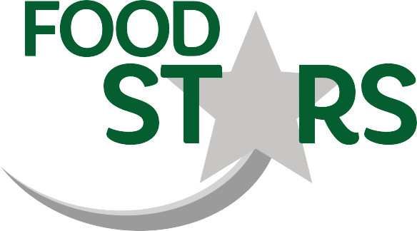

FEAST

Come and have lunch with Froggy!

Thursday 7th October

Froggy’s Favourites

Beef burger (H)

Or

Quorn Hotdog

*Served with chips and salad.*

Followed by

Chocolate cherry biscuits

or

**Choice of yoghurt or Fruit.**

**£2.25**

*Book your meal by 1/10 through the My Child at School App*

